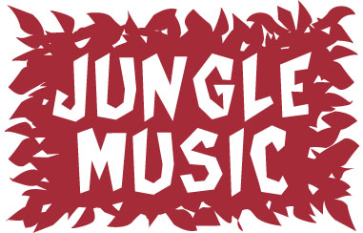

Welcome to our newest Forte Programme. This programme caters for 0-3 ½ age group and compliments the course programmes offered by Forte.

In the past, some Forte schools have offered a variety of programmes for young children; however none of these have fully met the needs of our schools or clients. We have investigated a range of programmes of the past three years looking at their strengths and weaknesses. At the end of 2002 a team was put together to develop this particular programme. Ideas have been trialled since February 2003, and lessons have been trialled in their current format for the last six months.

Our Goals for Jungle Music

We are excited to present an early childhood music programme that:
- Is cost effective.
- Is marketable and provides a programme that parents want.
- Maintains the integrity of a developmentally appropriate early childhood philosophy.
- Utilises high quality course materials and classroom equipment.
- Uses multi sensory learning styles as the foundation for learning.

The Course:

Clients | Children & parents/carers
Target age | 6mths-3 ½ yrs
Class Size | 3 – 10 children
Lesson time | 30-40 mins
Frequency | One lesson per week
Course duration | 20 -24 weeks

Where Jungle Music fits into our early childhood music programmes.

Jungle Music |  | Music Is Fun |  | Junior Keys
6mths – 3 ½ yrs |  | 3 ½ - 4 ½ yrs |  | 4 ½ +
Developmental Model |  | Both Developmental and Skills Based |  | Skills Bases Model
- Immerses children in a variety of musical experiences  - Children absorb what they are ready for developmentally  - Caters for a wide range of ages  - Hard to pinpoint children's progress on specific skills, generalised progress over time. |  | - Assumes minimal entry musical skills.  - Developmentally based structure combined with building and repletion of skills.  - Broad based musical appreciation.  - Introduction to keyboard skills. |  | - Sequential building of skills.  - Emphasis on keyboard skills.  - Individual progress easy to measure.  - Children need to be similar in age and musical experience.

What you will need to run Jungle Music.

A Classroom | Classroom & chairs (for baby/walkers)
Classroom Equipment
Teachers Manual & CD
CD player
Client materials (Book and CD)
Starter Kit (Bag and instruments ) | Under development
Merchandising | Under development

Progression through Jungle Music Themes

 |  | Jan 04 | July 04 | Jan 05 | July 05 | Jan 06 | July 07
 |  | Forest | Sea | Farm | Home | Forest | Sea
Babies | 6 mths- 12 mths
Walkers | 12 mths -18 mths
Tots | 18 mths – 2 yrs
 | 2 yrs - 2 ½ yrs
Friends | 2 ½ yrs – 3 yrs
 | 3 yrs – 3 ½ yrs
MIF | 3 ½ yrs +

Ages and stages

Babies (6 mths – 12 mths) and Walkers (12 mths – 18 mths)
- Child is immersed in a musical environment
- Development of sensory awareness is important
- Movements and interactions guided by parent
- Mothers are guided to respond to the child in a musical way
- Beginnings of discovery play
- Use music to help you parent

Tots (18 mths – 2 ½ years)
- Developing independence – more autonomous behaviour
- Discovery play
- Building of language skills to allow child to reflect and anticipate experiences.
- Child’s attention is focussed on particular elements. Parent guides the child's responses.
- Independent movement.
- Developing awareness of others.
- Parents as support, encouraging and helping the child as needed.

Friends (2 ½ - 3 ½ yrs)
  - Development of concepts.
  - Higher level processing – colour, number
  - Child is beginning to use language skills to socialise and manage their responses.
  - More control of body coordination and movement.
  - More ability to transfer learning from one activity to another.
  - Child is able to respond musically in an independent manner.
  - Parents as partners, sharing the experience with the child.
  - Greater emphasis on fine motor control.
Jungle Music – An Early Childhood Perspective
Personal
Self esteem
Feelings of competency through mastery of skills
Intellectual

Multi sensory input; stimulating the child's visual, kinaesthetic and auditory senses.
Focussing the child's attention on particular stimuli.
Physical
Balance
Motor co-ordination
Sensory awareness
Fine motor control
Visual skills

Emotional
Building on loving bond between parent and child
Social
Awareness of others
Pro-social skills

Musical
Pitch
Beat
Rhythm and metre
Form
Dynamics
Tempo
Timbre

Jungle Music Philosophy

JUNGLE MUSIC is an early childhood music programme designed to build a foundation of music skills.
JUNGLE MUSIC responds to the developmental needs of the young child.
JUNGLE MUSIC utilises the principles of multi sensory learning.

JUNGLE MUSIC responds to the developmental needs of the young child:
Personal | Through activities that build mastery and self esteem
Emotional | By responding to the loving bond between parent and child
Social | By welcoming you child into a group setting where they can learn to share, take turns and enjoys playing co-operatively
Physical | By developing co-ordination, balance, sensory awareness, visual skills and fine motor control
Intellectual | By stimulating your child's senses and focussing your child's attention on musical concepts in a playful way.
Musical | By building a foundation of music skills.

Multi Sensory Learning

Each of the class elements emphasizes different kinds of sensory stimulation.

Circletime  VAK | Locomotor  AK | Sensory/Body Awareness  K | Visual  V
Bonding  K | Instruments  AK | Notation  V | Laprides  AK
Number & Colour Concepts  V | Fingerplays  VAK | Cultural Awareness  A | Transitions  VAK

All learning occurs within the social context of the child's world.

Visual

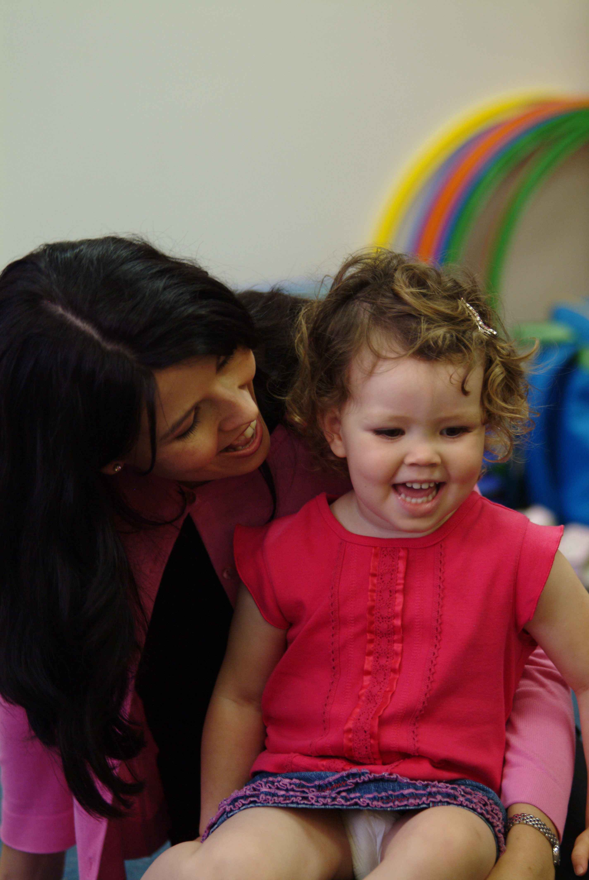

World Culture

Western Culture

Music classroom

The family
The child
Kinaesthetic
Auditory

Body Solfege | Bonding | Circletime | Locomotor | Instruments | Sensory
Forest Friends Jump Up On Me | All the Pretty Horses | Listen to the Rain | Birdie, Birdie | Listen to the Rain | Spotty Speckled Frogs
 | Hush-a-bye | I’m a Star | I’m A Sleepy Lion | I’m a Star | Ten Little Fingers
 | It’s The Right Time | Jungle Ring–a-Rosey | Run Rikki  Heigh-di-ho | Little Red Caboose / Down By the Station | Two Slippery Snakes
 |  | Round and Round the Circle | See How I’m Bouncing | Come and Play With Me | Where Are Your Eyes?
 |  | Little Red Caboose / Down By the Station |  | I Like the Flowers | Fred the Flea
 |  | Gypsy Rover/Galway Piper |  | Jungle Jam
 |  | La Bamba |  | Gypsy Rover/Galway Piper
 |  | Autumn Leaves |  | La Bamba
 |  |  |  | See How I’m Bouncing
 |  |  |  | Run Rikki /Heigh-di-ho
 |  |  |  | Feathers
 |  |  |  | Little Green Frog
Visual | Peekaboo | Lapride | Fingerplay | Notation
Butterfly | Molly Hides | Bruno Goes To Town | Whoops Bella | Three Butterflies
Flutterby | Molly in a Box | Giddiup | Beehive | Stomp
Little Boy Blue | Peekaboo, I See You | Rikki In The Tree | What Do You Suppose?
Autumn Leaves | Please Molly | Ten Little Ponies
Feathers | Where’s My Darling Peek-a-boo? | Whoops a Daisy
Little Green Frog |  | See How I’m Bouncing
Der Glumph |  | Whoops Bella
Lesson Element Categories - Forest

Jungle Music Lesson Elements

Activity | Purpose of the activity
Circle games | - This a group experience promoting social awareness and a feeling of working together.  - These activities use whole body movement to enable child to experience a musical skill such as beat, dynamics and tempo.
Locomotor activities | - These activities develop the children's whole body response to music, enhancing balance and gross motor coordination.
Instrument play | - The children are introduced to both tuned and untuned percussion instruments.  - Babies and small toddlers use instruments to discover and experience sound textures.  - Older toddlers and young children use percussion and pitched instruments to respond musically to rhythm, pitch, beat, sound texture and tempo.
Sensory Play | - Through sensory play, parents are taught how to use the sense of touch to stimulate their child's sensory awareness.  - For babies this may be a massage or calming activity  - For more active older children, sensory play will involve learning the names of body parts and body awareness activities.
Lap Rides | - These are fun parent and child activities that build the child's sense of beat and rhythm through whole body movement.
Visual | - These activities focus on a visual stimulus to build the child's visual awareness and eye tracking skills. These skills build a foundation for co-ordination of eye muscles vital for beginning reading.
Fingerplays | - Fingerplays are used to build finger movements and eye hand co-ordination needed for later school work and keyboard playing.
Notation | - Notation activities introduce children to reading music in a fun way through specially designed play materials.
Partner play | - We highly value the importance of parental input into the child’s musical education. Partner play builds on this loving bond using delightful peekaboo games, lullabies and partner games to encourage both a loving and musical interaction.

Lesson Plan Icons – Forest Friends

All the Pretty Horses | 9 |  | Jungle Jam | 13
Autumn Leaves | 22 |  | Jungle Ring-a-Rosey | 3
Birdie, Birdie | 5 |  | La Bamba | 20
Butterfly | 15 |  | Listen To The Rain | 23
Come and Play With Me | 8 |  | Little Boy Blue | 30
Der Glumph | 14 |  | Little Green Frog | 4
Feathers | 11 |  | Little Red Caboose/Down By The Station | 21
Forest Friends Jump Up On Me | 26 |  | Peekaboo, I See You | 16
Fred the Flea | 7 |  | Round and Round the Circle | 12
Giddiup | 10 |  | Run Rikki/ Heigh-di Ho | 2
Gypsy Rover/Galway Piper | 28 |  | See How I’m Bouncing | 27
Hush-a-bye | 31 |  | Spotty Speckled Frogs | 24
I like Flowers | 6 |  | Ten Little Fingers | 18
I’m a Sleepy Lion | 19 |  | Where Are Your Eyes? | 25
I’m a Star | 17 |  | Where’s My Darling? | 29
It’s The Right Time | 1

Beanbags I | 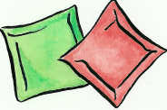 |  | Molly I | 
Beanie Toys I | 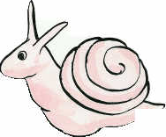 |  | Parachute I | 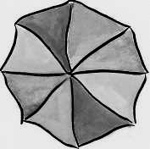
Bells I | 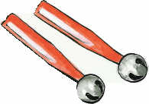 |  | Peekaboo Bag I | 
Bruno I |  |  | Rainbow Ring I | 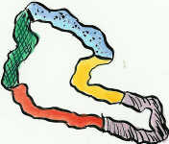
Chime Bars I | 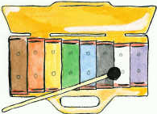 |  | Rainshaker I | 
Drum I | 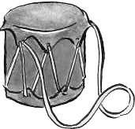 |  | Rhythm sticks I | 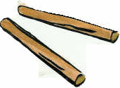
Egg Shakers I | 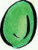 |  | Ribbon sticks I | 
Feathers I |  |  | Scarf I | 
Frog Beanbag I | 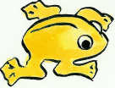 |  | Sleepy Bella I | 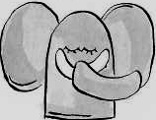
Hoops I |  |  | Stomp I | 

(Leave Blank)

